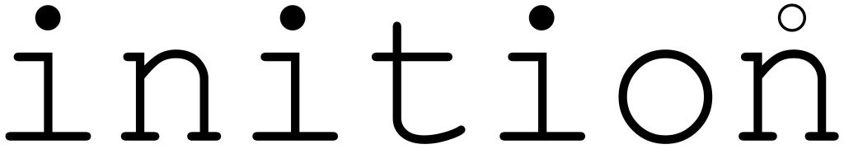

PRESS RELEASE: FOR IMMEDIATE RELEASE

Starlight Express tour world’s first for Inition 3D projection

The U.S. touring production of Andrew Lloyd-Webber’s Starlight Express, designed by John Napier for Troika Entertainment, features the world’s first entertainment use of a British-designed stereoscopic video projection system.
The ‘Duality’ projection system, designed by London-based 3D imaging specialists Inition, recreates the race track action that was an integral part of the original stage show at the Apollo Victoria, London.
Touring north American theatres, playing no more than a week in each city, meant the logistics of building the racetrack in each theatre were impossible to achieve.
So the producers turned to a completely new solution – full colour, high-resolution 3D back projection, using a specially developed high-brightness Duality rig.
Although 3D projection has featured in themed entertainment installations, this is the first time it has gone on the road. “The key elements,” says Inition technical director James Gant, “are the high definition digital movie playback system and our Duality stereoscopic projection system, consisting of four 7700 lumen UXGA projectors.”
Although 3D film projection has been around almost since the invention of movies, until recently digital projection systems have lacked the resolution and brightness to create sufficiently large scale 3D images for use in theatres.
The specifications of the playback system are demanding - two frame-synchronised UXGA (1600 x 1200) video channels at 30fps, along with 8 channels of audio. Inition worked with Muich-based IRIDAS who provided their Digital Cinema Playback System (DCPS) for the project. The DCPS playback systems are very compact, based on rackmounted Windows PCs from DVC in Germany.
One of the most important demands of the system was achieving adequate brightness for the 30-foot screen. Inition’s most powerful Duality projection system to date consists of four UXGA 7700-lumen projectors, two for each channel (or eye), offering a bright, crisp image at this scale. Rear projection was a must to avoid building a front of house projection tower. This meant that, because of space limitations in certain theatres on the tour, super wide-angle lenses were used allowing a throw distance of under 25 feet.
The stereoscopic effect is created by mounting polarising filters on the lenses and providing the audience with polarising 3D glasses. The video footage is projected through these filters onto a special, non-depolarising screen.
The makers of the 3D film, Principal Media, introduced Lloyd-Webber’s Really Useful Group team to Inition during their work on the IMAX production of Giant Screen Bugs. Principal shot the race sequences using dual 70mm cameras and Inition provided a full-scale screening for Andrew Lloyd Webber in the IMAX cinema at Waterloo in London before it was shipped to the USA.
“I don’t think the audience realized that they were about to witness the real world debut of this technology, but once the show began they responded. Their gasps and ‘oohs’ made all the hard work worthwhile,” says Inition creative director Andy Millns. “From my experience, this is a common reaction when people see modern 3D projection for the first time. They just can’t believe how good it is. A voice informs the audience that the race is about to begin and instructs them to put on their ‘safety goggles’. The audiences love it!”
“This is not just a first in theatre,” adds Inition MD Stuart Cupit, “it’s a sign of things to come.”

BACKGROUND INFORMATION
Inition was formed in 2001 by Stuart Cupit, James Gant, Chris Sutton and Andy Millns. The team has a passion for 3D graphics and create a range of virtual reality (a.k.a. VizSim) and graphics products and services, including the recently launched Duality range of stereoscopic projection rigs.
Production manager for ‘Starlight Express’ is James Milburn; set moves are accomplished using an automated variable speed chain motor from Tomcat, and the set was fabricated by F&D Scene Changes of Calvary, Alberta. Christie Lites of Orlando, Florida supplied the lighting rig for lighting designer Rick Belzer. Sound is by Specialised Audio Visual Inc of New York, with sound designer Mark Norfolk and consultant Mick Potter.
The American touring production of Starlight Express is scheduled to run at least until the end of the 2003.

CONTACT DETAILS

James Gant / Andy Millns, Inition Ltd
Tel. +44 (0)20 7613 5004
Fax +44 (0)20 7613 2944
Email:inition@inition.co.uk
Web: http://www.inition.co.uk/
75 Curtain Road, London EC2A 3BS, United Kingdom

Mike Lethby / Sarah James, Gasoline Media
Tel: +44 (0)1372 744333
Fax: +44 (0)1372 744334
Email: info@gasolinemedia.com
Web: www.gasolinemedia.com

